Guinea-Bissau

## Freedom House political status

The data set shows the Freedom House political scores and status of the country each year.

## # A tibble: 19 x 5  
## country iso3c date mean status   
## <chr> <chr> <dbl> <dbl> <chr>   
## 1 Guinea-Bissau GNB 1996 3.5 Partly Free  
## 2 Guinea-Bissau GNB 1998 4 Partly Free  
## 3 Guinea-Bissau GNB 2000 4.5 Partly Free  
## 4 Guinea-Bissau GNB 2002 4.5 Partly Free  
## 5 Guinea-Bissau GNB 2003 5 Partly Free  
## 6 Guinea-Bissau GNB 2004 4 Partly Free  
## 7 Guinea-Bissau GNB 2005 3.5 Partly Free  
## 8 Guinea-Bissau GNB 2006 4 Partly Free  
## 9 Guinea-Bissau GNB 2007 4 Partly Free  
## 10 Guinea-Bissau GNB 2008 4 Partly Free  
## 11 Guinea-Bissau GNB 2009 4 Partly Free  
## 12 Guinea-Bissau GNB 2010 4 Partly Free  
## 13 Guinea-Bissau GNB 2011 4 Partly Free  
## 14 Guinea-Bissau GNB 2012 5.5 Not Free   
## 15 Guinea-Bissau GNB 2013 5.5 Not Free   
## 16 Guinea-Bissau GNB 2014 5 Partly Free  
## 17 Guinea-Bissau GNB 2015 5 Partly Free  
## 18 Guinea-Bissau GNB 2016 5 Partly Free  
## 19 Guinea-Bissau GNB 2017 5 Partly Free

## Freedom House classification of political change

The data set shows the GDP growth and the ecomic growth classification of the country each year.

## # A tibble: 19 x 4  
## country iso3c date politicalChangeFH  
## <chr> <chr> <dbl> <chr>   
## 1 Guinea-Bissau GNB 1996 no change   
## 2 Guinea-Bissau GNB 1998 autocratization   
## 3 Guinea-Bissau GNB 2000 autocratization   
## 4 Guinea-Bissau GNB 2002 no change   
## 5 Guinea-Bissau GNB 2003 autocratization   
## 6 Guinea-Bissau GNB 2004 democratization   
## 7 Guinea-Bissau GNB 2005 democratization   
## 8 Guinea-Bissau GNB 2006 autocratization   
## 9 Guinea-Bissau GNB 2007 no change   
## 10 Guinea-Bissau GNB 2008 no change   
## 11 Guinea-Bissau GNB 2009 no change   
## 12 Guinea-Bissau GNB 2010 no change   
## 13 Guinea-Bissau GNB 2011 no change   
## 14 Guinea-Bissau GNB 2012 autocratization   
## 15 Guinea-Bissau GNB 2013 no change   
## 16 Guinea-Bissau GNB 2014 democratization   
## 17 Guinea-Bissau GNB 2015 no change   
## 18 Guinea-Bissau GNB 2016 no change   
## 19 Guinea-Bissau GNB 2017 no change

## Freedom House score trend

The plot shows the Freedom House scores trend of the country.

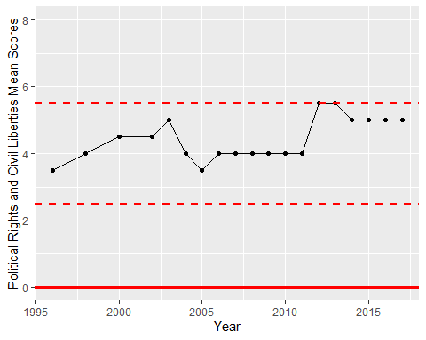

Freedom House Score Trend